My progress is too slow if I only work on 2 or 3 processes at a time. What should I do?
Overview
In our program, we teach that you should only focus on two or three processes to improve at any given time. Many learners feel their progression speed will be too slow if they restrict themselves to this pace. However, the reality is that this pace (which may appear slow) is likely the fastest way for someone to improve. The conflict lies in the learner's expectations vs. reality.
How learners often expect to improve
Many learners view skill development like adding tools to a toolkit. The more tools we have, the more equipped we will be to meet our challenges. While this is true to an extent and can be a useful analogy, the process of developing these skills (acquiring each tool) is more complicated.
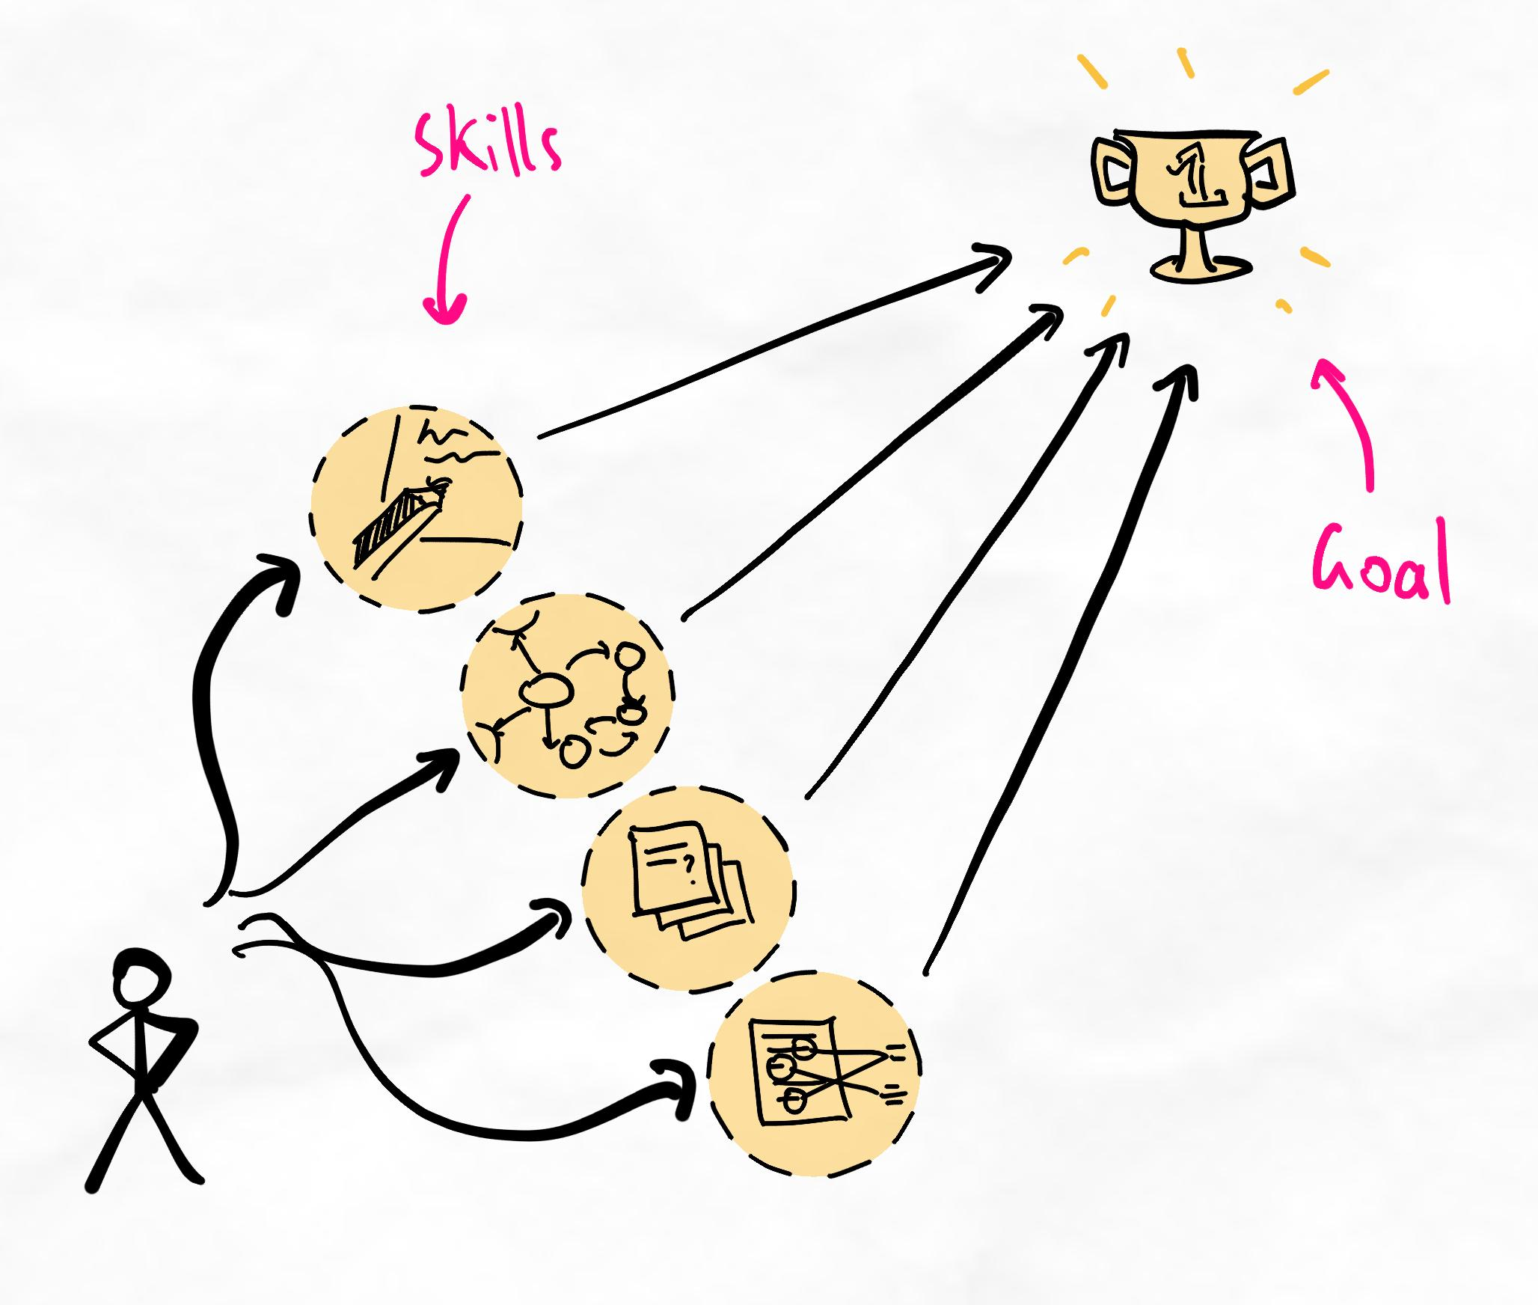When we think "more skills = better", the focus is on acquiring as many skills as we can.
The reality of skill development
Unfortunately, the process of acquiring skills is more like a computer solving a complex algorithm. Each skill has a set of variables that must be understood to acquire the skill correctly. Only after deciphering these variables can we use the skill. This takes time, effort, and processing power through mental energy and cognitive load.
When we try to develop too many skills simultaneously, we sacrifice our ability to acquire the skill, which increases confusion and frustration. By limiting the number of skills and processes we try to master at the same time, we improve our ability to acquire the skills quickly.
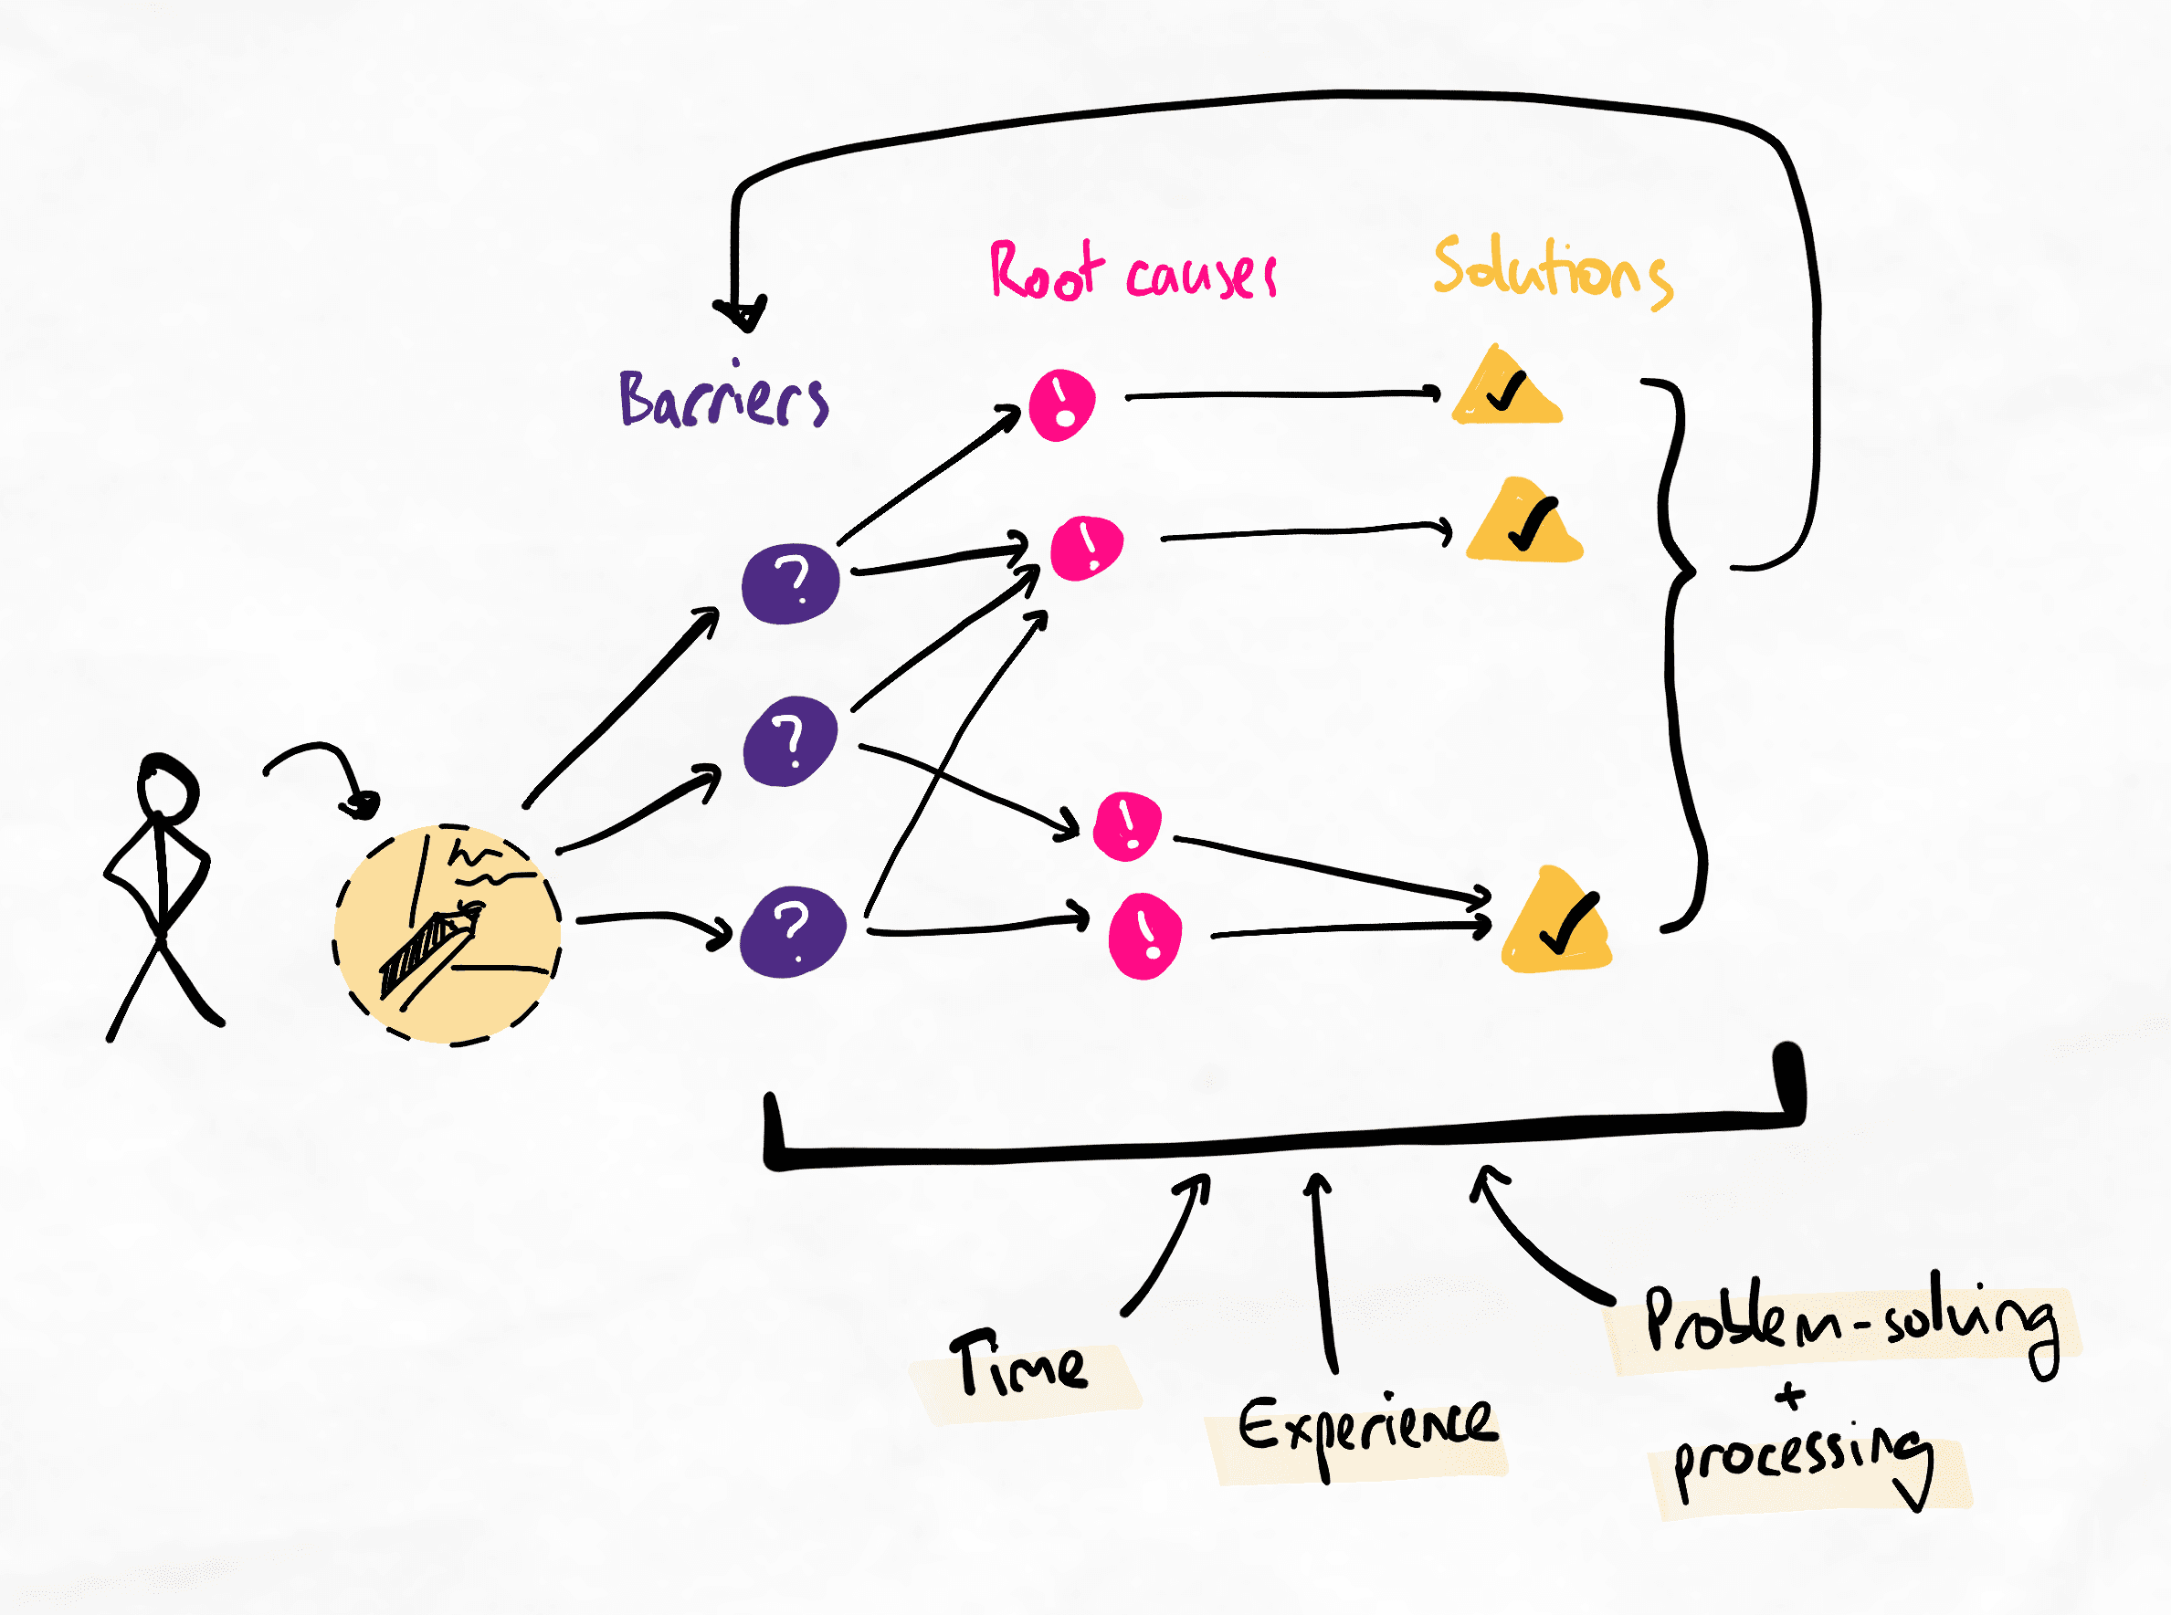In reality, skill development is more complex. Unravelling the complexity takes time, experience, and processing.
In the diagram above, you can see that the process of acquiring skills involves:
- Identifying barriers
- Analysing root causes that create those barriers
- Proposing solutions
- Repeating this process until there are no more barriers
This takes time, experience, and self-reflection, which helps us analyse and process experiences to turn them into learning opportunities.
By focusing on too many skills at the same time, we ultimately reduce our skill development speed because:
- Our limited time, effort, and energy is spread across too many experiences
- Our brain enters into overload as there are too many variables to keep track of simultaneously, creating confusion and increasing errors
We can't have it all!
Although it would be ideal to learn as many skills as we need all at the same time, this is unfortunately not realistic. Sometimes, the skills we need to acquire are greater than our ability to acquire them within a certain time period.
Example
Imagine a student who needs excellent critical thinking skills, excellent essay writing skills, excellent encoding and retrieval skills, and excellent time management skills to do well for an exam two months from now. However, if this student is starting from a baseline where each of these skills is at a very basic level, it is unlikely that they will be able to develop these skills in time. This is simply unrealistic.
As such, even if we need many skills, the best course of action is still to develop each skill as quickly as possible. To do this, we must counter-intuitively reduce the number of skills we try to acquire simultaneously.
By doing so, we improve our concentration and depth.

